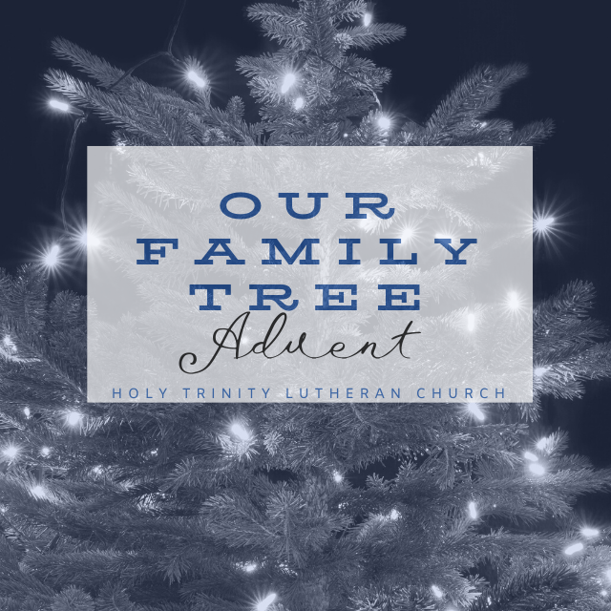
Family Connection Week One - Watch

Share highs and lows from the day
Read the Bible Story and article
Talk about how the story relates to your highs and lows.

Pray for one another’s highs and lows. Start out – God we pray for…and end with, Amen.

Bless one another.
Look at one another, say – God loves you!
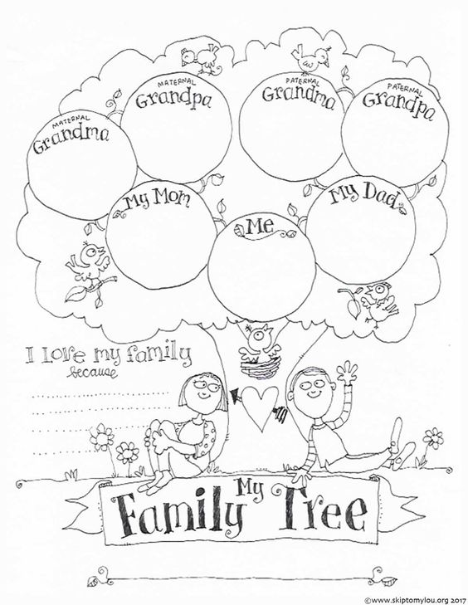

What is Faith 5? Go online at www.faith5.org to learn more! These are practices that are easy to do for the entire family. Do them at breakfast, driving in the car, or before you go to bed. Try it out!
Advent Week One Watch

Theme: We pay attention or watch how God listens to our prayers, provides for our families and creates a family story filled with grace.

Scripture: Genesis 17:15-21
God continued speaking to Abraham, “And Sarai your wife: Don’t call her Sarai any longer; call her Sarah. I’ll bless her—yes! I’ll give you a son by her! Oh, how I’ll bless her! Nations will come from her; kings of nations will come from her.”

Sarah had waited for God her entire life to have a child. She had a son at the age of over 100 years! Can you imagine something so – amazing? When she heard the news, she laughed. She was far from perfect; she was loyal and faithful. She is the matriarch of our family tree with her son, Isaac.

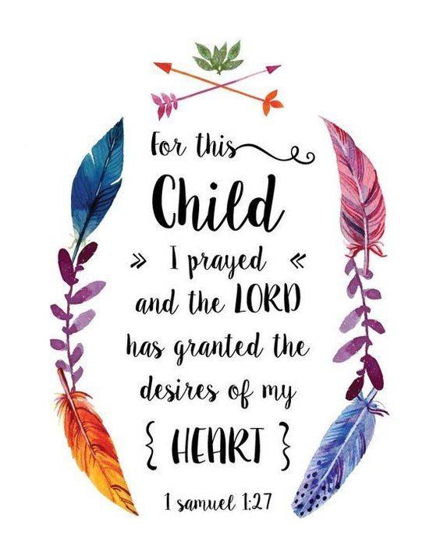
What is Faith 5? Go online at www.faith5.org to learn more! These are practices that are easy to do for the entire family. Do them at breakfast, driving in the car, or before you go to bed. Try it out!
Family Connection Week Two - Prepare

Share highs and lows from the day
Read the Bible Story and article
Talk about how the story relates to your highs and lows.

Pray for one another’s highs and lows. Start out – God we pray for…and end with, Amen.

Bless one another.
Look at one another, say – God loves you!

Advent Week Two Prepare

Theme: Prepare the way of the Lord.
Scripture: 1 Samuel 1-2

Our about story about Hannah is one that is very special It is a story of pain and a story of joy. It is a story of long ago and the promise of today! It is a story of faithfulness, love and devotion. There are some parts of the story that make sense if you know about early days of the Bible. Just like sometimes stories from our family history make more sense if we had lived, well, a long time ago. This week, find ways to talk with someone who is much older than you, like a grandparent. Ask them did they ever stay home from school because of widespread illness? Did they ever have to get a shot to prepare the body to stay well? What does it mean – to be faithfully prepared?

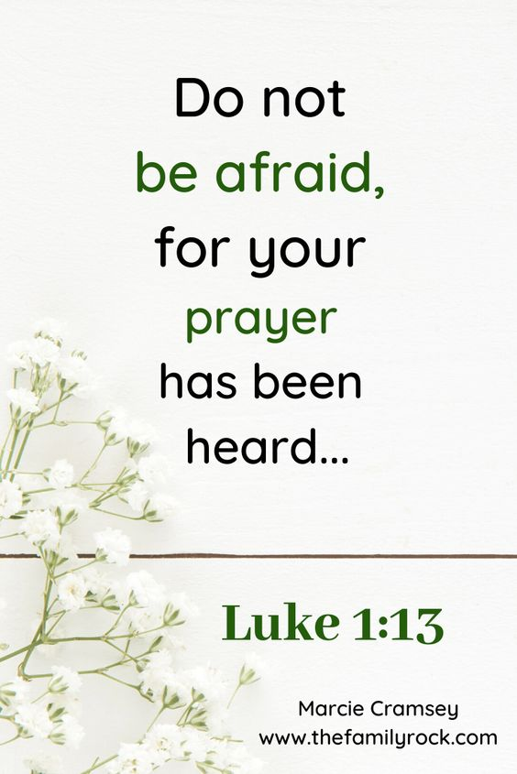
What is Faith 5? Go online at www.faith5.org to learn more! These are practices that are easy to do for the entire family. Do them at breakfast, driving in the car, or before you go to bed. Try it out!
Family Connection Week Three - Rejoice

Share highs and lows from the day
Read the Bible Story and article
Talk about how the story relates to your highs and lows.

Pray for one another’s highs and lows. Start out – God we pray for…and end with, Amen.

Bless one another.
Look at one another, say – God loves you!
Advent Week Three - Rejoice

Theme: God is at work in the faithful of all ages.

Scripture: Luke 1:5-80
When Elizabeth heard Mary’s greeting, the baby leaped in her womb, and Elizabeth was filled with the Holy Spirit. In a loud voice she exclaimed: “Blessed are you among women, and blessed is the child you will bear! But why am I so favored, that the mother of my Lord should come to me? As soon as the sound of your greeting reached my ears, the baby in my womb leaped for joy. Blessed is she who has believed that the Lord would fulfill his promises to her!” Luke 1:41-45 NIV
Elizabeth and Mary are cousins and they are very different in age! But they are both faithful and waiting for their sons, John the Baptist and Jesus to be born. Their relationship as women is beautiful, heartwarming, honest, and inspiring.
Can you name two friends in one of the shows you watch on TV or cable? Why are they friends? Are they good friends? Do they take on challenges together and see the good in life? When is the last time you called your friend?

Family Connection Week 4 Behold!

Share highs and lows from the day
Read the Bible Story and article
Talk about how the story relates to your highs and lows.

Pray for one another’s highs and lows. Start out – God we pray for…and end with, Amen.

Bless one another.
Look at one another, say – God loves you!
What is Faith 5? Go online at www.faith5.org to learn more! These are practices that are easy to do for the entire family. Do them at breakfast, driving in the car, or before you go to bed. Try it out!

Advent Week Four Behold

Theme: God is at work. The light of God is with us.
Scripture: Luke 1:46-56 and Luke 2:1-20

Share stories about driving around town looking at Christmas lights. How does looking at Christmas lights make you feel? Do you feel hope, that God is with us?

Mary was young and now expecting a baby. In our scripture we hear her talk to the angels. She is at first afraid, then in awe, and then her heart is full of happiness. Why do you think her feelings changed? Mary could God’s story of grace included – her!

These 2020 Advent Season has been – certainly one of a kind. But so was the season that Mary waited to give birth to our one-of-a-kind Savior, Jesus Christ.
There is still time – to take a huge PAUSE in the busyness of our lives and take these final days of 2020 remember stories from this year, stories before 2019 and then think of stories that – could be in 2021!
The angels spoke to Mary and didn’t just tell her what was going to happen and then leave her there – they listened as she told them she was afraid. They told her this promise – that all things are possible with God!
This is our promise too – that God is always with us. That God sees our hurts and struggles, our joys and laughter and says – forgiveness, mercy, compassion and LOVE are always possible with God.
What gift are you praying for – tonight?
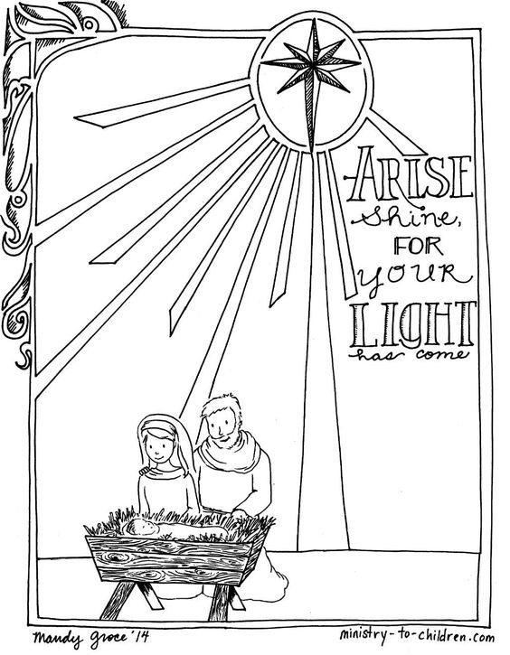
Our Family Tree “Giving Tree” opportunities during Advent 2020

Looking for impactful gifts and donations this Christmas? Check out the opportunities below and connect the stories of giving from Our Family Tree to stories of giving in your household. You may drop off donations between 8:30 a.m. – noon Monday through Friday or on Wednesday evenings 6-8 p.m. or Sunday Mornings 8:30-noon. Please check the church calendar or call ahead to make sure the doors are open. Questions? Call the church office.
Mitten and Hat Tree – 4 th Annual Drop off new mittens and hats for school age children. Donations will be shared with elementary schools after the holidays when students first round of mittens and hats have gone lost or given to younger brothers and sisters. In the past several years, we have served classrooms where there can be up to eight different languages spoken all in the same room. Donations provide much needed warmth!
Comfy and Cozy Tree – NEW! Donations of children’s PJ’s, Socks, and under garments are needed for children (infant-18 years of age) in shelters – especially when it is cold outside! Please consider purchasing a second set that you would typically purchase for your child or grandchild for the Comfy and Cozy Tree. We are also asking for diapers to go under the tree for newborns through large!
ELCA Good Gifts Tree – Annual Event From goats to water wells, ELCA Good Gifts make a life-changing difference in the world. ELCA Good Gifts let you provide critical help to families in need. Gifts start at $10. Donate for the purchase of chicks, piglets, pair of goats, clean water, school supplies, bees, missionary support and so much more. You will make your donation directly by reaching out to: Goodgifts.elca/org
Trees Forever – Derecho Recovery Trees Forever is a non-profit organization which is housed in Marion that has been around for years. The goal is to adopt, plant, rehabilitate, and restore wooded areas. With the tree devastation caused by the August Derecho in Marion, Cedar Rapids, Hiawatha, Robins, Solon and other area more than ever a donation to plant a tree is a meaningful lifelong legacy. Connect directly with treesforever.org for more information

